Camera update manual V1.1.5
1.Input the Camera IP or IP range if need to update more cameras at the same time,and then click Add .
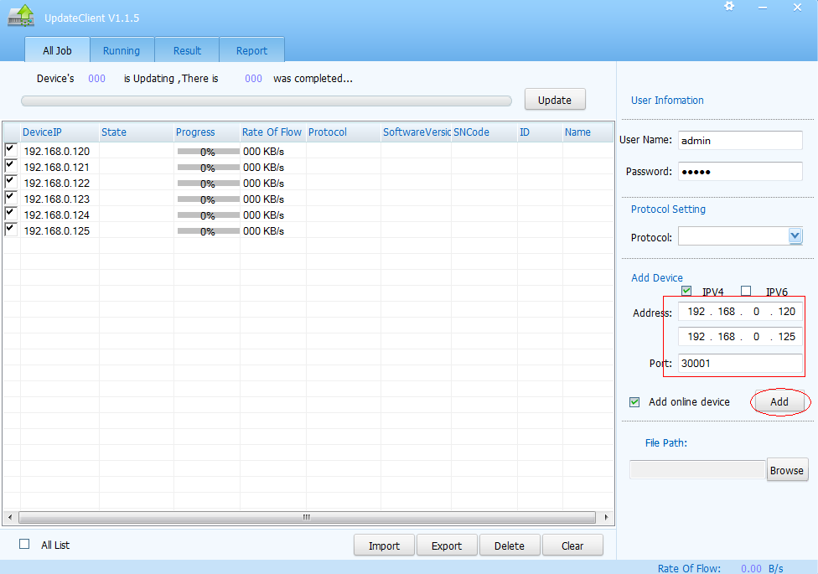

2.Select the Firmware that need to update and click Update
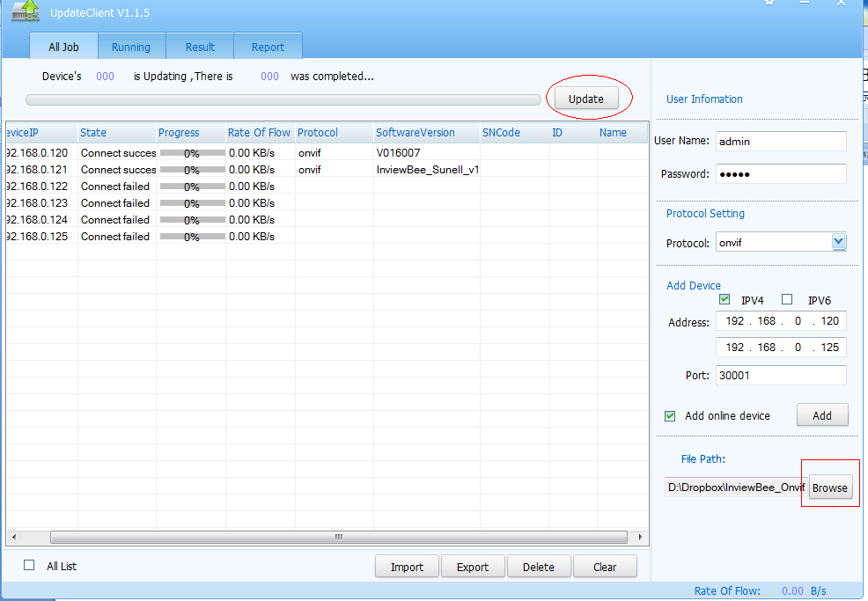

3.Wait for the update process finish.
