Update firmware when cameras seems to hang.

- Connect the camera to LAN ,then try to ping it such as the camera IP is 192.168.0.120
“ping 192.168.0.120 –t “
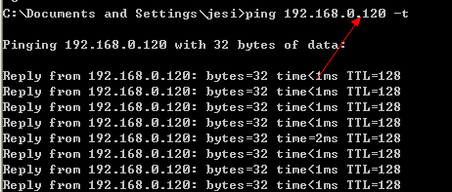

- If you can ping and see the continuous data return then do the next follow steps.
If can’t Ping please check the PC IP gateway must be same with camera.
If sure the Camera IP and PC IP is same gateway and still can’t Ping the camera (no data return), then we can’t fix this camera, only can fix by reply hardware (mostly Mainboard).
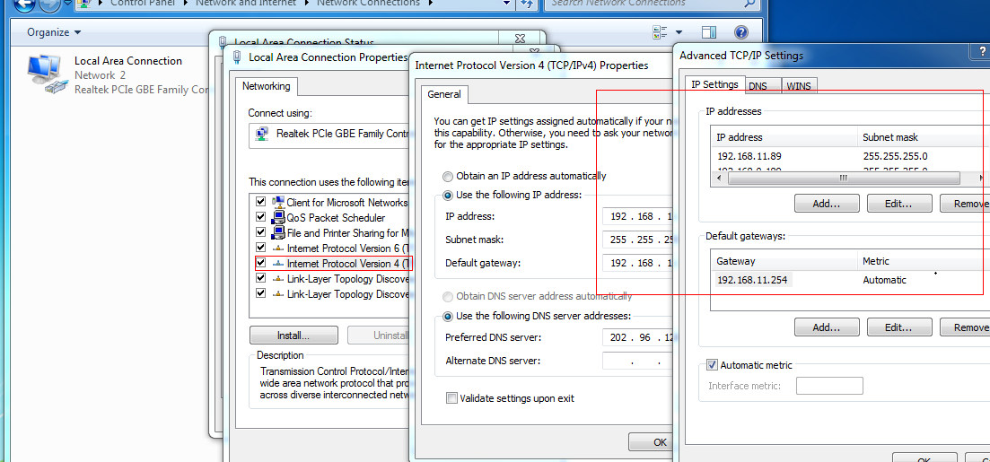

- After see the continuous data return, Run the Update tool and finish the Step 1 to Step 3, still wait not to Click update (Step 4).

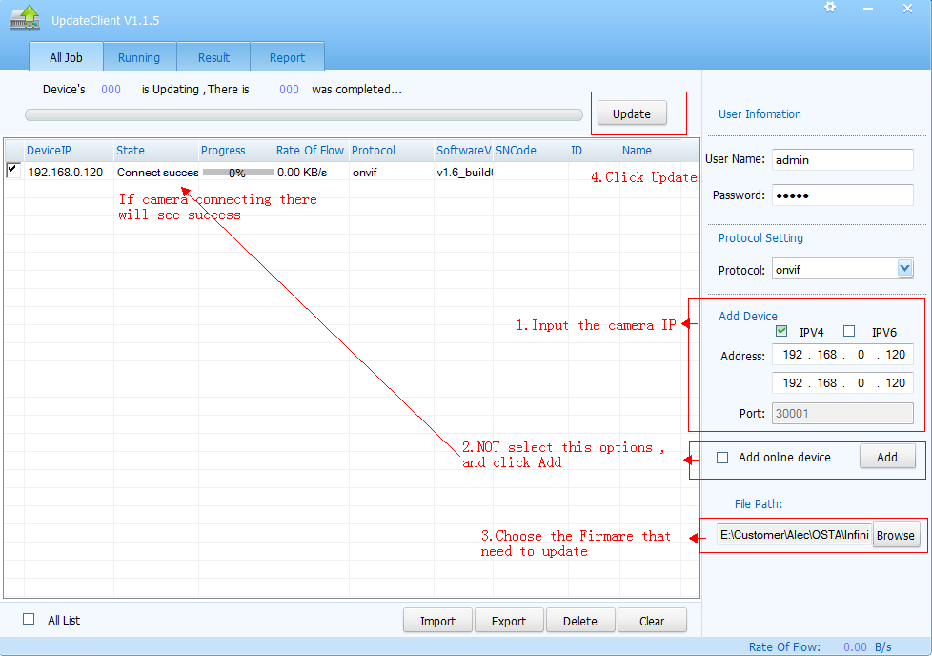

- Still Keep the Ping running, then manually restart the Camera by off power and Turn ON and when you once see the Ping data return and Click Update to finished Step 4.
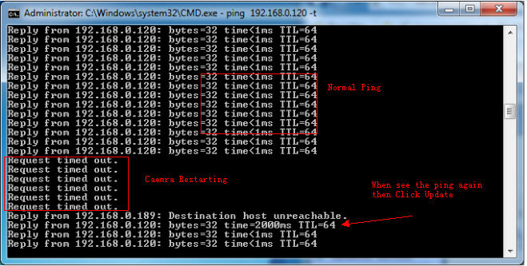

Sunell technology

